

**Artificial Intelligence Project Report**

**AI in Smart Shopping**

|  |  |  |
| --- | --- | --- |
| Registration No. | Name | Roll No. |
| 12111901 | Jaswanth Pentakota | 61 |
| 12116404 | Nitin | 62 |
| 12115115 | Harshit Sharma | 63 |

**Branch:** B-Tech CSE **Course Code:** INT404

**Submitted to:** Akshara Rana **Section:** K21QT

**Abstract­**

With the rise of Artificial Intelligence (AI) technology, the retail industry has undergone a significant transformation. The use of AI in smart shopping has provided a more efficient and personalized shopping experience. AI can help retailers gain insights into customer behaviour, improve inventory management, and enhance the overall customer experience. This report provides an in-depth analysis of AI in smart shopping, including its functions, data and knowledge resources, shortcomings, and applications. Customer behaviour analysis is a crucial function of AI in smart shopping, as it provides retailers with insights into customer preferences and behaviour patterns. By analysing customer data, AI algorithms can help retailers to make better decisions about product placement, pricing, and promotions. This, in turn, can improve sales and enhance the overall customer experience.

The data and knowledge resources used in AI for smart shopping include customer data, product data, sales data, and social media data. These data sources provide retailers with valuable information about customer behaviour, product attributes, pricing, and availability. However, the use of customer data raises privacy concerns, and the implementation of AI in smart shopping can be challenging due to the significant investment in technology and infrastructure.

In conclusion, AI has revolutionized the retail industry and has provided retailers with powerful tools to gain insights into customer behaviour, optimize inventory management, and enhance the overall customer experience. However, the implementation of AI in smart shopping requires careful consideration of potential privacy concerns and challenges. The continued development of AI technology and its applications in the retail industry will undoubtedly shape the future of smart shoppingTop of Form

**1] Introduction**

AI in smart shopping is a concept that has emerged with the integration of AI technology into the retail industry. In recent years, the retail industry has seen significant transformations, and AI has played a crucial role in this transformation. The use of AI has enabled retailers to analyse customer behaviour, optimize inventory management, and enhance the overall customer experience. This report provides an overview of the various functions of AI in smart shopping and the data and knowledge resources used in this context.

**Overview-**

The report would explain how AI technologies, such as machine learning, natural language processing, and computer vision, are being applied to various aspects of smart shopping, including personalized recommendations, virtual try-ones, chatbots, and smart checkouts.

The report would highlight the benefits of using AI in smart shopping, such as increased efficiency, improved customer satisfaction, and enhanced data analytics. For example, AI-powered personalized recommendations can help customers find products that are tailored to their preferences, while chatbots can provide instant customer support and reduce wait times.

However, the report would also address some of the challenges and ethical considerations associated with the use of AI in smart shopping, such as privacy concerns and the potential for bias in AI algorithms. The report would offer recommendations for how retailers can ensure that these technologies are used in a responsible and ethical manner, such as by being transparent about how customer data is used and ensuring that AI algorithms are regularly audited for fairness and accuracy.

**Objective-**

The objective of a report on the topic of AI in smart shopping would be to explore the ways in which AI technology is being used in the retail industry to enhance the shopping experience for customers. The report would provide an overview of the various AI applications that are being used in smart shopping, such as personalized recommendations, virtual try-ons, chatbots, and smart checkouts. It would also examine the benefits of using AI in smart shopping, such as increased efficiency, improved customer satisfaction, and enhanced data analytics.

**2] Application of AI in Smart Shopping**

**AI-Powered Product Recommendations**:

One of the primary functions of AI in smart shopping is to provide product recommendations to customers. AI algorithms analyse customer data such as purchase history, browsing behaviour, and social media activity to suggest products that customers are likely to be interested in. This function enhances the shopping experience by providing personalized recommendations and can increase sales for retailers. AI-powered recommendations are now a standard feature of many e-commerce platforms, and physical stores are also adopting smart shelves that can suggest complementary or alternative products to customers.

**AI-Powered Inventory Management:**

AI is also being used to optimize inventory management in smart shopping. AI-powered systems can track inventory levels in real-time, analyse sales trends, and make predictions about demand. This helps retailers to optimize their inventory levels, reducing waste and improving profitability. AI-powered inventory management also helps to avoid stockouts by predicting when products are likely to run out, allowing retailers to order more stock in advance.

**AI-Powered Customer Service:**

AI is transforming customer service in smart shopping by providing 24/7 support through chatbots and other AI-powered systems. Chatbots can answer common questions, provide product recommendations, and even process orders. Smart mirrors and shopping assistants are also being developed to help customers find products in-store and suggest outfits based on their body shape and style preferences. This function of AI in smart shopping enhances the shopping experience by providing personalized assistance and improving the efficiency of customer service.

**AI-Powered Fraud Detection:**

AI is also being used to detect fraudulent activity in smart shopping. As online shopping becomes more popular, fraudsters are finding new ways to commit fraud. AI algorithms can analyse large volumes of data to detect patterns of fraudulent activity and prevent fraudulent transactions. This function of AI in smart shopping helps to protect retailers and customers from financial loss and maintain trust in the shopping experience.

**Supply Chain Optimization**

AI can be used to optimize the supply chain in the retail industry. By analyzing data from suppliers, manufacturers, and distributors, AI algorithms can help retailers to optimize the supply chain and reduce costs.

**3] Data and Knowledge Resources**

**3.1] Customer data**

Customer data is one of the most important resources for AI in smart shopping. It provides valuable insights into customer behaviour, preferences, and needs. There are several types of customer data that are used in AI for smart shopping, including demographic data, purchase history, and behaviour patterns.

**Demographic Data**

Demographic data provides information about customers' age, gender, location, and other characteristics. This data can be used to segment customers into different groups based on their preferences and needs. For example, a retailer may use demographic data to create personalized promotions targeted to specific customer groups, such as millennials or seniors.

**Purchase History**

Purchase history data provides information about customers' past purchases. This data can be used to predict future purchases and make personalized product recommendations. For example, a customer who frequently purchases running shoes may be recommended new releases in that category.

**Behaviour Patterns**

Behaviour pattern data provides insights into customers' browsing behaviour and interactions with a retailer's website or app. This data can be used to identify patterns in customer behaviour and predict future actions. For example, a retailer may use behaviour pattern data to identify when a customer is likely to abandon their shopping cart and intervene with personalized incentives or recommendations. Customer data can be collected through a variety of channels, including in-store purchases, online shopping, and mobile apps. Retailers can use data analytics and machine learning techniques to process and analyse customer data in real-time, providing personalized and timely recommendations and promotions to customers.

However, it is important to note that customer data must be handled in a responsible and ethical manner. Retailers must ensure that customer privacy is protected, and that data is used only for legitimate business purposes. Additionally, customers must be informed about how their data is being collected and used and must have the option to opt-out of data collection if desired.

**3.2] Product Data**

Product data is another essential resource for AI in smart shopping. This data includes information about product attributes, pricing, availability, and other important details. There are several types of product data that retailers can use to improve their customers' shopping experiences.

**Product Attributes**

Product attribute data includes information about the physical characteristics of products, such as size, weight, colour, and material. This data can be used to create detailed product descriptions and to provide customers with accurate and relevant information about products.

**Pricing Data**

Pricing data includes information about the cost of products, including regular prices, sale prices, and discounts. This data can be used to create personalized pricing promotions for customers based on their purchase history and behaviour patterns. For example, a retailer may offer a discount to a customer who frequently purchases a specific product.

**Availability Data**

Availability data includes information about product inventory levels, as well as delivery times and options. This data can be used to provide customers with accurate information about when products will be available, and to manage inventory levels more effectively.

Product data can be collected through various channels, including manufacturer catalogues, supplier databases, and internal inventory management systems. Retailers can use data analytics and machine learning techniques to process and analyse product data in real-time, providing customers with accurate and relevant information about products.

AI can also use product data to make personalized product recommendations to customers. For example, if a customer frequently purchases products in a certain category, AI algorithms can recommend related products that the customer may be interested in.

In conclusion, product data is a crucial resource for AI in smart shopping. By leveraging this data, retailers can provide customers with accurate and relevant information about products, as well as personalized product recommendations and promotions. However, it is important to ensure that product data is accurate and up-to-date, and that retailers comply with regulations related to product labelling and disclosure.

**3.3] Sales Data**

Sales data is another important resource for AI in smart shopping. This data provides valuable insights into customer behaviour patterns and helps retailers to predict future demand. There are several types of sales data that retailers can use to improve their customers' shopping experiences.

**Sales Volume**

Sales volume data includes information about the total number of products sold, as well as sales by category, brand, and other attributes. This data can be used to identify trends and patterns in customer behaviour, and to make decisions about product offerings and pricing strategies.

**Revenue Data**

Revenue data includes information about total sales revenue, as well as revenue by category, brand, and other attributes. This data can be used to track the performance of products and categories, and to make decisions about inventory management and pricing strategies.

**Margins Data**

Margins data includes information about the profit margins on products, as well as margins by category, brand, and other attributes. This data can be used to identify which products and categories are the most profitable, and to make decisions about pricing strategies and inventory management.

Sales data can be collected through various channels, including point-of-sale systems, online transactions, and mobile apps. Retailers can use data analytics and machine learning techniques to process and analyse sales data in real-time, providing insights into customer behaviour patterns and predicting future demand.

In conclusion, sales data is a crucial resource for AI in smart shopping. By leveraging this data, retailers can identify customer behaviour patterns and predict future demand, as well as provide customers with personalized product recommendations and promotions. However, it is important to ensure that sales data is accurate and up-to-date, and that retailers comply with regulations related to sales data.

**3.4] Social Data**

Social data is becoming an increasingly important resource for AI in smart shopping. This data includes customer feedback, reviews, and sentiment analysis. Social media platforms, such as Facebook, Twitter, and Instagram, provide retailers with valuable insights into customer preferences and opinions.

**Customer Feedback**

Customer feedback data includes information about customer opinions and experiences with products and services. This data can be used to identify areas for improvement and to make decisions about product offerings and customer service.

**Reviews Data**

Reviews data includes information about product reviews and ratings, as well as customer feedback on social media platforms. This data can be used to identify trends and patterns in customer behaviour, as well as to make decisions about product offerings and pricing strategies.

**Sentiment Analysis**

Sentiment analysis data includes information about the emotional tone of customer feedback and reviews. This data can be used to identify customer sentiment towards specific products, brands, and categories, and to make decisions about marketing strategies and customer service.

Social data can be collected through various channels, including social media platforms, review websites, and customer service feedback systems. Retailers can use data analytics and machine learning techniques to process and analyse social data in real-time, providing insights into customer preferences and opinions.

AI can also use social data to make personalized product recommendations to customers. For example, if a customer frequently leaves positive reviews for products in a certain category, AI algorithms can recommend related products that the customer may be interested in. However, it is important to ensure that social data is accurate and up-to-date. Retailers must also comply with regulations related to data privacy and security, as well as with platform-specific guidelines related to customer reviews and feedback.

In conclusion, social data is a crucial resource for AI in smart shopping. By leveraging this data, retailers can identify customer preferences and opinions, as well as provide customers with personalized product recommendations and promotions. However, it is important to ensure that social data is accurate and up-to-date, and that retailers comply with regulations and guidelines related to data privacy and security.

**4] AI Techniques Used**

There are several AI techniques used in smart shopping, each with its own unique purpose and benefits. Here are some explanations of the most common AI techniques used.

**4.1] Computer vision**

Computer vision is a critical component of smart shopping, where retailers use technology to enhance the customer experience and optimize their operations. In smart shopping, computer vision uses algorithms and models to analyse visual data, such as images or videos, to extract valuable insights that can inform business decisions.

One of the main applications of computer vision in smart shopping is in-store analytics. Retailers use computer vision systems to analyse data from cameras installed in stores to gain insights into customer behaviour and preferences. These systems can detect and track customer movements, identify popular products, monitor inventory levels, and detect anomalies such as theft or accidents. Retailers can then use this information to optimize store layouts, product placement, and promotional campaigns to improve the customer experience and drive sales.

Another application of computer vision in smart shopping is in product recognition. Computer vision systems can analyse images of products and identify specific features such as brand, colour, or style. This information can be used to assist customers in finding products or to optimize inventory management by identifying which products are selling well and which are not.

**4.2] Natural Language Processing (NLP)**

It is a field of artificial intelligence (AI) that focuses on enabling machines to understand and process human language. In smart shopping, NLP is used to analyse customer reviews, feedback, and social media posts to identify trends, preferences, and issues that can inform product development and marketing strategies.

One of the key applications of NLP in smart shopping is sentiment analysis. NLP algorithms can analyse customer feedback, such as product reviews or social media posts, to identify the sentiment expressed by the customer. This can help retailers understand how customers feel about their products, services, and brand, and identify areas for improvement.

Another application of NLP in smart shopping is in chatbots. Chatbots are computer programs that simulate human conversation using NLP and machine learning techniques. Retailers use chatbots to assist customers with product inquiries, provide recommendations, and facilitate transactions. NLP algorithms enable chatbots to understand and respond to customer queries in natural language, providing a seamless and personalized customer experience.NLP can also be used to analyse customer feedback and identify topics or themes that are important to customers. This information can help retailers identify customer needs and preferences and develop products and services that meet those needs.

Overall, NLP is a powerful tool in smart shopping that can help retailers gain insights into customer behaviour, preferences, and needs. By analysing customer feedback and interactions, retailers can optimize their operations, develop better products and services, and provide a seamless and personalized customer experience.

**4.3] Predictive Analytics:**

In smart shopping, predictive analysis is a powerful tool that retailers use to make data-driven decisions and optimize their operations. Predictive analysis uses statistical algorithms and machine learning techniques to analyse historical data and make predictions about future events or trends.One of the key applications of predictive analysis in smart shopping is demand forecasting. Retailers use predictive analysis to forecast demand for specific products or categories, allowing them to optimize their inventory management and reduce waste. By analysing historical sales data, seasonality, and other factors, predictive analysis can help retailers accurately predict future demand, and adjust their inventory levels and supply chain accordingly.

Overall, predictive analysis is a critical component of smart shopping that enables retailers to make data-driven decisions and optimize their operations. By leveraging historical data and machine learning techniques, retailers can improve their demand forecasting, pricing strategies, and customer experience, leading to increased sales and profitability.

**5] Case Studies**

**5.1] Amazon Go:**

Amazon's checkout-free grocery stores use a combination of computer vision, deep learning algorithms, and sensor fusion to track customers as they enter and leave the store. Customers can simply grab the items they want and walk out, and their Amazon account is charged automatically. The system can detect when items are taken off the shelf, and it can also detect when items are put back. The technology behind Amazon Go is called "Just Walk Out."

**5.2] Walmart Intelligent Retail Lab:**

Walmart's Intelligent Retail Lab is an AI-powered store in Levittown, New York, that uses cameras and sensors to monitor inventory levels, track when items are running low, and alert staff when it's time to restock. The system also uses machine learning to identify when a product needs to be replenished based on historical sales data.

**5.3] Alibaba's Fashion AI:**

Alibaba's Fashion AI uses computer vision and deep learning to provide shoppers with personalized fashion recommendations. Shoppers can upload a photo of themselves, and the system will analyse their body shape and suggest clothes that will fit them well. The system also considers the shopper's style preferences, purchase history, and the latest fashion trends.

**5.4] H&M's Smart Mirror:**

H&M's smart mirrors use AI to help customers find the perfect outfit. Shoppers can use the mirror to try on different outfits, and the mirror will suggest other items that would complement the outfit. The mirror also uses voice recognition technology to allow customers to control the mirror with their voice.

**5.5] Kroger's EDGE Shelf:**

Kroger's EDGE Shelf is an AI-powered display that uses cameras and sensors to detect when a customer is in front of the display. The display can then show personalized ads and product recommendations based on the customer's purchase history and demographic information.

These are just a few examples of how AI is being used in smart shopping. As the technology continues to advance, we can expect to see even more innovative uses of AI in the shopping experience**.**

**6] Implementation (Chatbot)**

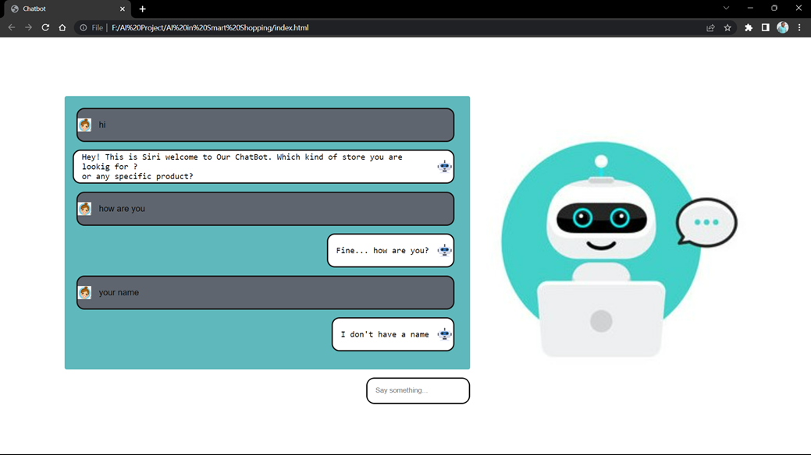Chatbots can be used in smart shopping to provide personalized assistance to shoppers, answer questions, and help them find the products they're looking for. Here are some ways in which chatbots can help in smart shopping:

**Personalized Recommendations:**

Chatbots can use machine learning algorithms to analyse a shopper's browsing history and purchase behaviour to provide personalized product recommendations. This can help shoppers discover new products that they may be interested in.

**Customer Support:**

Chatbots can be used to provide 24/7 customer support to shoppers. They can help with common queries such as tracking order status, return policies, and shipping information, freeing up human customer service representatives to handle more complex issues.

**Product Search:**

Chatbots can help shoppers find products by asking questions about their preferences, such as size, colour, and style. They can also search the store's inventory and provide information about product availability.

**Order Placement:**

Chatbots can help shoppers place orders by guiding them through the checkout process, providing product recommendations, and suggesting add-ons or complementary products.

**Upselling and Cross-selling:**

Chatbots can be used to suggest additional products or services that complement a shopper's purchase, such as accessories or warranty plans.

Overall, chatbots can provide an efficient and personalized shopping experience, which can help retailers increase customer satisfaction and sales. As AI technology continues to evolve, we can expect chatbots to become even more sophisticated and helpful in smart shopping.

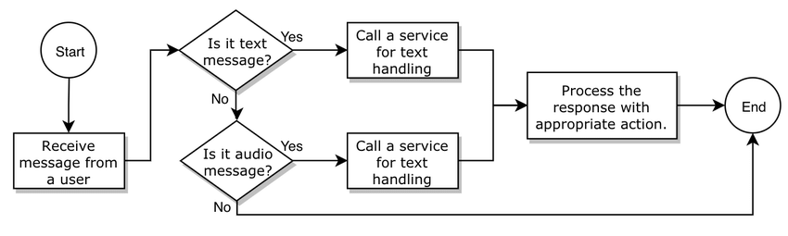**Flow chart and Use Case for Chatbot:**

**(Flow-chart)**

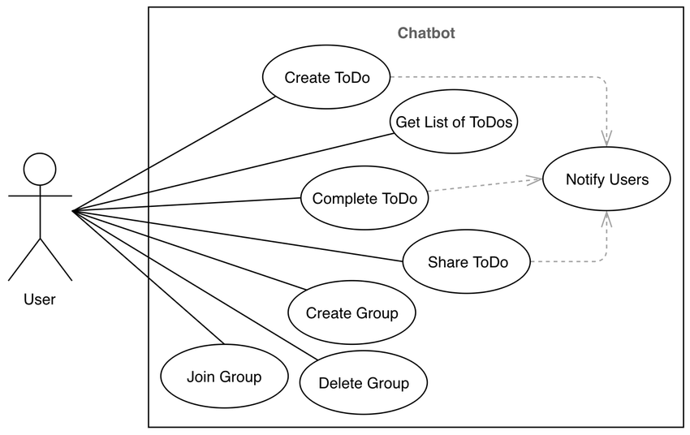

**(Use Case)**

**7] Ethical Considerations**

**Privacy:**

One of the primary ethical concerns of AI in smart shopping is privacy. AI systems collect and analyse vast amounts of customer data, including personal information such as purchase history, location data, and even biometric data. Customers may be concerned about how their data is being collected, stored, and used, particularly if it is being shared with third-party companies or used for advertising purposes. Smart shopping systems must be transparent about how customer data is being collected and used and provide customers with the ability to control their data.

**Bias:**

Another ethical consideration of AI in smart shopping is bias. AI systems can inadvertently perpetuate existing biases, particularly if they are trained on biased data sets. For example, a recommender system may recommend certain products or services to customers based on their race, gender, or other personal characteristics. Smart shopping systems must be designed and trained to avoid biases and ensure that they treat all customers fairly.

**Customer Manipulation:**

Another ethical concern of AI in smart shopping is customer manipulation. AI systems can be used to manipulate customer behaviour and preferences, such as by providing personalized discounts or using persuasive language to encourage customers to make a purchase. While these tactics may be effective in increasing sales, they may also be seen as manipulative or even unethical. Smart shopping systems must balance the need to increase sales with the need to respect customer autonomy and avoid manipulative tactics.

**Job Loss:**

Finally, AI in smart shopping has the potential to lead to job loss, particularly in retail and customer service industries. AI systems can automate many tasks that were previously performed by human employees, such as inventory management, customer service, and even checkout. While this can increase efficiency and reduce costs for retailers, it can also lead to job loss and economic disruption for workers. Smart shopping systems must consider the impact on workers and work to mitigate the negative effects of automation.

Overall, these ethical considerations highlight the need for responsible and ethical AI design and implementation in smart shopping systems. Retailers must be transparent about how customer data is being used, avoid biases and customer manipulation, and consider the impact on workers as AI systems are implemented.

**8] Future Trends**

**Advancements in AI Technology:**

Advancements in AI technology are expected to drive the future of smart shopping. As AI technology continues to improve, smart shopping systems will become more accurate, efficient, and effective at predicting customer behaviour and providing personalized recommendations. This could include advancements in machine learning, natural language processing, and computer vision, as well as the development of new AI techniques and algorithms.

**Integration of AI in Physical Retail Stores:**

The integration of AI in physical retail stores is also expected to be a major trend in the future of smart shopping. Retailers can use AI systems to analyse customer behaviour in physical stores, such as tracking foot traffic and monitoring customer interactions with products. This data can be used to optimize store layouts, improve product placement, and enhance the overall shopping experience.

**Increased Personalization:**

Another trend in the future of smart shopping is increased personalization. As AI systems become more sophisticated, they will be better able to analyse customer data and provide personalized recommendations and deals in real-time. This could include personalized pricing, customized promotions, and even personalized product design.

**Augmented Reality Shopping:**

Finally, augmented reality shopping is expected to be a significant trend in the future of smart shopping. Augmented reality (AR) technology enables customers to visualize products in 3D and in real-world settings, helping them to make more informed purchase decisions. AR shopping experiences could include virtual try-ons, product visualizations, and even virtual showrooms.

**Voice-Activated Shopping:**

Voice-activated shopping is another trend in the future of smart shopping. With the increasing popularity of smart speakers and voice assistants, retailers can integrate voice-activated shopping into their AI systems. Customers can use voice commands to search for products, place orders, and even make payments. This technology provides a hands-free and convenient shopping experience that can help retailers to increase customer engagement and loyalty.

**Integration with Internet of Things (IoT) Technology:**

Integration with Internet of Things (IoT) technology is also expected to be a major trend in the future of smart shopping. IoT devices, such as smart refrigerators and wearable devices, can collect data on customer behaviour and preferences, which can be used to personalize shopping experiences and improve product recommendations. For example, a smart refrigerator could detect when a customer is running low on milk and automatically place an order for more. By integrating AI with IoT technology, retailers can provide a more seamless and personalized shopping experience for their customers.

Overall, these future trends highlight the potential of AI in smart shopping to enhance the overall shopping experience, increase efficiency, and drive sales. As AI technology continues to evolve, retailers must remain agile and innovative to keep pace with changing customer expectations and demands.

**Roles and Responsibilities:**

|  |  |
| --- | --- |
| REQUIRMENT ANALYSIS | Harshit Sharma |
| DESIGN | Nitin |
| CODING & TESTING | Coding and Testing |

|  |
| --- |
|  |

**Gantt Chart**

**Progress of work schedule in terms of Gantt chart**

|  |  |  |  |  |
| --- | --- | --- | --- | --- |
| **Task Name** | **Start**  **Date** | **End**  **Date** | **Duration (Days)** | **Days Complete** |
| Requirement analysis | 4/3/23 | 7/3/23 | 3 | 3 |
| Design | 7/3/23 | 11/3/23 | 4 | 4 |
| Coding | 11/3/23 | 4/4/23 | 25 | 25 |
| Testing | 5/4/23 | 15/4/23 | 10 | 10 |

**References**

**Research Gate** Comparison of the Development of Native Mobile Applications and Applications of Facebook Platform *July 2019*In book: Mobile Web and Intelligent Information Systems (pp.85-94)

**IOP Conference Series**: Materials Science and Engineering AI SHOPPING SOLUTION - The Smartest All-in-One Shopping Solution *Soumyajit Paul, Pritam Mahapatra, Maheswar Banerjee and Tapas Kumar Nandi.* Published under licence by IOP Publishing Ltd

Link: <https://doi.org/10.1088/1757-899X/1080/1/012011>

**International Journal of Scientific Research in Computer Science, Engineering and Information Technology ISSN: 2456-3307 (www.ijsrcseit.com)** Research on Smart Shopping Cart *Prof. Roopa* , *Nivas Chandra Reddy* ,Electrical and Electronics Engineering, VTU, New Horizon College of Engineering, Bangalore, Karnataka, India , Business Consulting, Ernst and Young LLP, Bangalore, Karnataka, India

Link: <http://ijsrcseit.com/>

**Journal of Computer Science Research | Volume 02 | Issue 01 | January 2020**

Review of Artificial Intelligence with Retailing Sector *Venus Kaur, Vasvi Khullar, Neha Verma* School of Information Technology, Vivekananda Institute of Professional Studies, Delhi, India

Link: http://ojs.bilpublishing.com/index.php/jcsr